Sbongkwanda Simelane

PROGRAMMING 2A POE

PROG6221

1. **Screenshot of the GitHub repository showing the commit history up to the Part1 tag.**

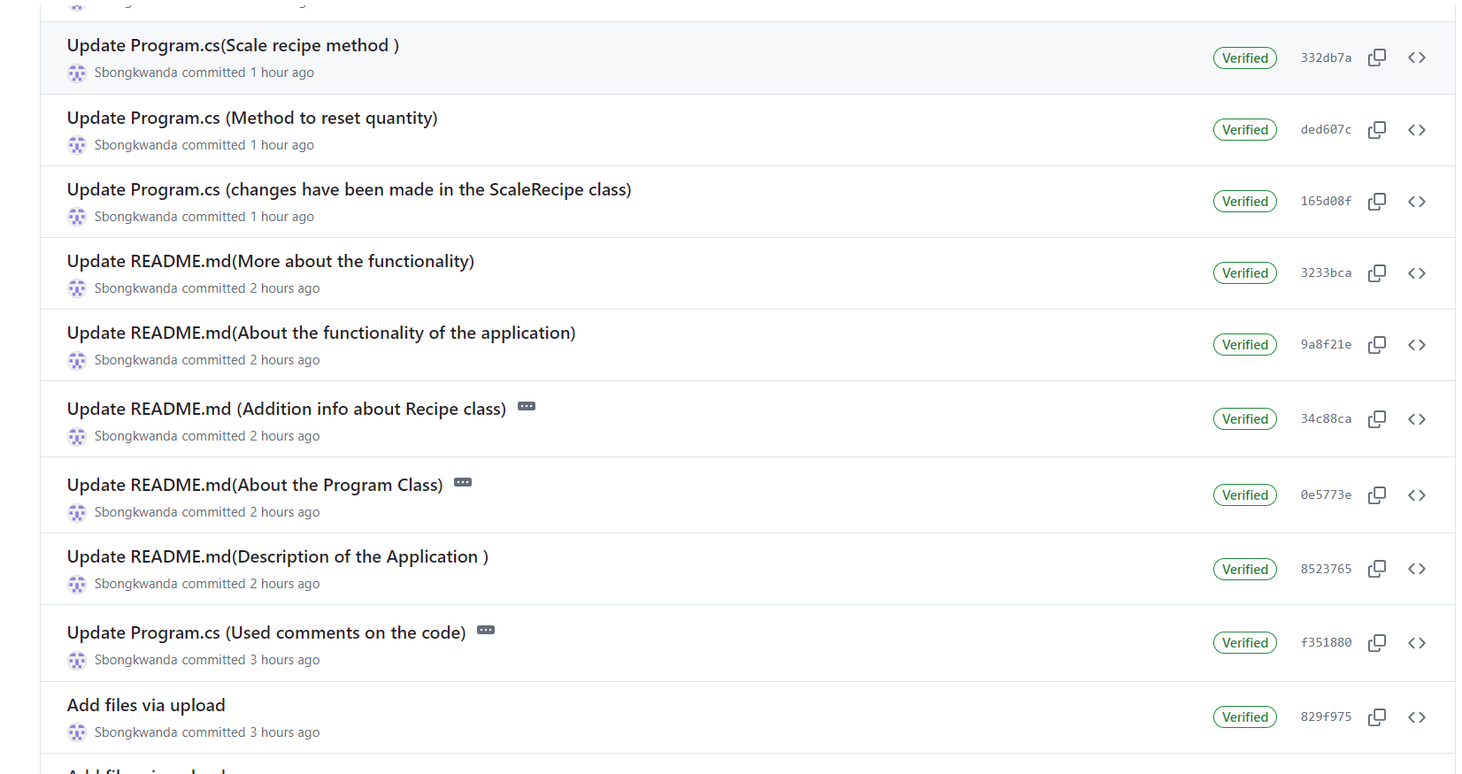

2. A link to the GitHub repository.

GitHub Link: <https://github.com/IIEMSA/programming-2a-part1-new-Sbongkwanda>